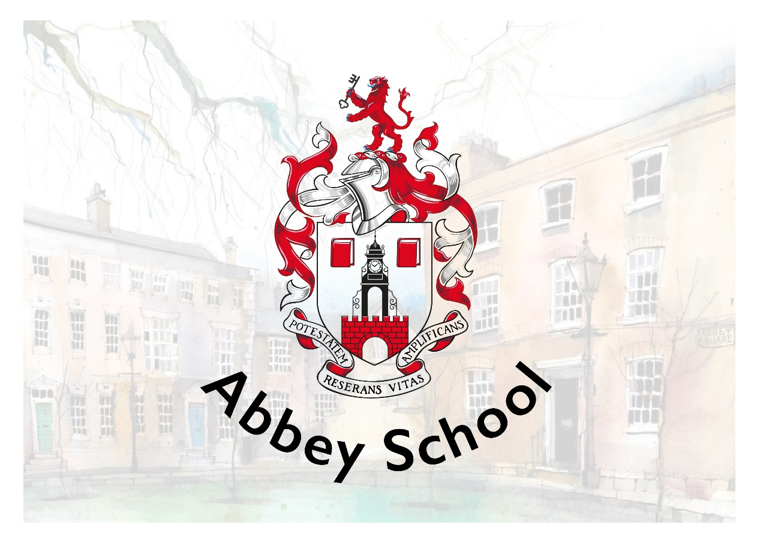

RECRUITMENT PACK
KS4/5 SEND CLASSROOM TEACHER (MATERNITY COVER)

Abbey School
10-12 Abbey Square
Chester, CH1 2HU
recruitment@abbeyschool.com
01244 960000



CONTENTS

Welcome from the Principal 3
About our School 4
Benefits 10
How to Apply 11
Deadline 11
Shortlisting and Interviews 11
Start Date 11
Safeguarding Statement 12
Equal Opportunities Statement 12
Working in Chester 13

Welcome from the Principal
Welcome and thank you for your interest in Abbey School.
Our Independent Special school provides a unique environment of high-quality, evidence-informed education, nurture and care to young people aged 4-19 with autism, whom may have additional learning difficulties and behaviours that challenge. We offer a comprehensive programme of support which ensures that all of our pupils’ individual needs are met through highly personalised learning.
We are privileged to benefit from a truly wonderful location. Our school is housed in stunning Grade II* listed buildings, part of historic Abbey Square in the heart of the beautiful city of Chester. Our fantastic team of architects have designed a well-equipped and high-tech learning environment for us, whilst maintaining the beauty of the buildings and surroundings for our pupils to enjoy. We make full use of our environment and location with a creatively designed curriculum that includes focused learning and enrichment activities that support wellbeing. This enables all of our young people to experience growth, development and success.
Our highly skilled and specialist staff team includes teachers, learning and behaviour specialists, speech and language therapists and occupational therapists. This trans-disciplinary focus ensures that each pupil’s individual needs are understood, accurately planned for and closely monitored as part of day-to-day school practice.
I am extremely proud to be the Principal of Abbey School, a place where pupil-centred practice is the norm and where the voice of the young people we support and their families is central to all that we do. It really is a very special place to work and learn.
Yours sincerely
Dr Katy Lee

About our School
Abbey School is an Independent Special School for young people aged 4-19 with autism, whom may have additional learning difficulties and behaviours that challenge. We provide high-quality education and care in our beautiful Grade II* listed buildings in the heart of Chester. All young people attending Abbey School have an Education, Health and Care Plan (EHCP) with school places commissioned and funded via local authorities. We work in close partnership with families and carers with support, information sharing and workshop opportunities available throughout the academic year.
Abbey School is aspirational for all of the young people that we support. This aspiration is captured in our vision, mission and values which are central to all that we do at Abbey School.
Vision
Our vision is that all children with exceptional needs receive a meaningful and fulfilling education that enables them to make their own choices about the direction of their adult lives.

Mission
Abbey School exists to provide the best education possible for young people with exceptional needs.
- Every pupil is a unique individual with potential
- Special educational needs and/or disability should not be a barrier to a valued lifestyle
- All children and young people without exception are entitled to access the best education and support available
- Best practices in education are evidence-based
- Teaching and learning decisions should be evidence-driven
- Clear goals make data-based decisions more numerous and effective
- Education is for everyone and for the whole of a person’s life
- Learning is enabling, empowering and extends the boundaries of autonomy
- If a pupil is not learning, it is the teaching that needs to change – the learner is always right
- Pupil voice should be heard and respected

Values
Our whole school approach brings together everything that is known from special education research and best practice to maximise pupil learning and wellbeing. We are an innovative learning organisation. Our day-to-day working practices routinely inform research, evaluation and development. We have a bespoke curriculum, designed by us, specifically to meet the needs of our pupils.

Each pupil’s journey through the curriculum is personalised. Approaches to teaching and learning are individualised, goal-based and precisely assessed. The curriculum is delivered by transdisciplinary teams who benefit from a high level and intensive internal training programme.

Our unique APPs support staff in planning and monitoring each pupil’s learning journey on a moment-to-moment basis. We are centrally located in the heart of the city which provides many opportunities for community-based learning, live skills development and supported work placements as young people get older.

Every decision we make is framed in the context of the Abbey School BAGS model:
B – Belonging and connection – being part of a community and having a network of valued relationships.
A – Autonomy and control – having influence over day-to-day and life defining matters.
G – Gifts and talents – doing even better the things that are done really well, and learning to do things that are important but may not be done at all.
S – Speaking, listening and a sense of self – communicating effectively in a variety of ways not just speech, and having an identity that defines who I really want to be.

Job Description

Job Title | KS4/5 SEND Classroom Teacher(maternity cover) | Team | Abbey School
Starting Salary | MPS + 1 SEN point | Reporting to | Phase Lead
Working Hours | 35 hours per week | Line Manages | Senior Learning Mentors, Learning Mentors

This role is not suitable for ECT’s.
We are seeking an experienced SEND Teacher who has significant teaching experience within a SEND setting, including the delivery of qualifications/accreditations and supporting work related learning programmes.

Role Purpose
- Planning, preparing and delivering learning activities to Key Stage 4/5 pupils that promote an enjoyment of learning, pupil progress and experience a sense of wellbeing.
- Creating a positive learning environment, reflective of the school’s culture and ethos.
- Leading a class team to provide outstanding teaching and learning for Key Stage 4/5 pupils.
- Assessing, recording and reporting progress for Key Stage 4/5 pupils.
- Preparing for and contributing to Person Centred Reviews.
- Working in partnership with parents, colleagues and other professionals to achieve the best possible outcomes for Key Stage 4/5 pupils.

Responsibilities and Role
Teaching and Learning
- Plan and implement appropriate teaching and learning activities to achieve challenging learning objectives in all areas of the curriculum, appropriately tailored to meet the individual needs of Key Stage 4/5 pupils.
- Work within Abbey School’s Positive Behaviour Policy and framework to improve the quality of children and young people’s lives; establishing appropriate behaviour for learning and helping them to work with other people.
- Support Key Stage 4/5 pupils to experience positive wellbeing through appropriate learning and leisure activities and by creating a supportive ethos within the class.
- Establish productive working relationships with Key Stage 4/5 pupils, acting as a role model, and setting high expectations.
- Direct and support other members of the team so they develop and use their skills to provide a rich curriculum and a positive learning experience for Key Stage 5 pupils.
- Support and oversee inclusion for Key Stage 4/5 pupils through experiences in other schools, colleges and work experience schemes.
- Plan and lead educational visits, including Work Experience placements to meet the needs and interests of Key Stage 4/5 pupils.
- Work with other members of the team to create classroom and corridor displays that celebrate progress and support learning.

Assessment, Target Setting and Recording Progress
- Provide feedback to Key Stage 4/5 pupils in relation to their progress and achievement, and support them where they can to assess their own learning.
- Maintain objective and accurate records and reports on achievement, progress and other matters, collating appropriate evidence and entering data into the school systems accurately and in a timely manner.
- Prepare for Person Centred Reviews and contribute to them to ensure that achievements are celebrated and key issues raised, discussed and actions agreed.

Partnership Working
- Support parents to contribute to their child’s learning by sharing information with them in meetings or through written communication, and by taking account of their views in planning and teaching.
- Liaise effectively with other professionals, including members of your Teaching Team, to design and implement learning programmes for individuals and to ensure a rich and varied curriculum.
- Make referrals to other professionals where appropriate in discussion with the leadership team.
- Represent the school at external / multi-disciplinary meetings

Leadership and Management
- Provide effective line management for the Learning Mentors in your class team to support their effective performance and professional development.

Personal and Professional Development and School Improvement
- Take an active part in training and other development opportunities and apply what is learnt to improve teaching and learning.
- Participate in Abbey School’s Appraisal process.
- Contribute to training and development for colleagues, including supporting members of the team to complete external and internal CPD, including accredited courses.
- Take responsibility within a named area of the curriculum as directed by the Principal, for example co-ordinating resources, identifying training opportunities or planning enrichment activities within the named area.
- Contribute to reviewing and improving the curriculum.
- Attend meetings called by school.

Common Accountabilities and Dimensions within all Roles
- Demonstrate the vision and values of Abbey School in everyday practice, upholding the school’s ethos at all times.
- Actively contribute to the culture of Abbey School as a learning organisation.
- Be responsible for ensuring that your own practice is consistent with Abbey School policies and procedures.
- Be responsible for your own effective professional communication, orally and in writing, to the right people at the right time.
- Be responsible for ensuring that your own responsibilities and accountabilities are clearly defined and understood and for managing your work and working proactively with your manager to that end.
- Be responsible for the health and safety of others using proactive and reactive approaches. This may include using positive handling techniques such as Team-Teach.
- Uphold Abbey School policies to protect and safeguard pupils and vulnerable adults in order to secure their health, safety and wellbeing.
- Support pupils with intimate care (such as toileting, nappy changing, dressing and feeding), and the administration of medicine as required by the needs of the pupils.
- Ensure that any personal care offered to pupils maintains their dignity, promotes their independence and account of all relevant policies.
- Be responsible for ensuring that personal use of resources is efficient and effective and actively upholds Abbey School’s policies.
- Assume personal responsibility for implementing the school’s policy on Equal Opportunities and inclusion for all staff and pupils.

General
- To undertake any reasonable task in line with requirements of the role under the direction of the Principal.
- This role involves regulated activity with children and adults and so an Enhanced DBS with Children and Adult Barred List Checks is required.

Person Specification
Criteria | Essential Qualities | Desirable Qualities
Qualifications | - Honours degree and QTS or equivalent teaching qualification | - Additional SEND-specific qualifications
Experience | - Recent experience working within a SEND school, college or setting  - Experience of delivering a pupil-centred, highly personalised curriculum that promotes engagement and achievement  - Experience of supporting learners who may present behaviours that challenge | - Experience of teaching pupils with learning difficulties and Autistic Spectrum Condition  - Evidence of continuous professional development, preferably including issues related to SEN  - Experience of evidence-based intervention processes to raise achievement
Knowledge | - Secure understanding of the SEND Code of Practice and EHCP processes  - Understanding of the issues surrounding the safeguarding of children and a commitment to child welfare and safety  - Understanding of KS4 and KS5 curriculum pathways, accreditations and qualifications | - Knowledge of positive behaviour support approaches to managing behaviour  - Knowledge of vocational pathways and accreditation bodies  - Knowledge of multidisciplinary working with therapists, social care and external agencies
Skills | - Strong classroom management tailored to SEND needs  - Excellent communication with pupils, parents and multi-agency teams  - Excellent personal organisational skills  - Ability to build positive relationships with pupils, parents and carers | - Ability to use assistive technology and adaptive resources  - Skilled in developing personalised learning plans
Leading a team | - Experience of effectively line managing support staff  - Ability to work flexibly as part of a team  - High expectations of self and colleagues  - Effective written and oral communication | - Experience of leading a curriculum area or accreditation programmes  - Experience delivering staff training or coaching
Personal Attributes | - A passion for improving outcomes for young people with SEND  - A child-centred approach to the profession  - High expectations for all learners  - Calm and professional under pressure  - Physically fit and active to meet the demands of the role  - Emotionally resilient | - Leadership potential for curriculum development  - Creative approach to engaging learners
Other Requirements | - Enhanced DBS clearance | - Willingness to undertake CPD in SEND and vocational education

Benefits
- Competitive salary
- Suite of staff benefits including pension scheme
- Technology appropriate for your job
- Comprehensive staff training programme
- Access to Health Hero Employee Assistance Programme.
- Access to MediCash program for wellbeing benefits
- The opportunity to shape and improve the life chances of pupils with a disability, and in so doing, extend the prospect of an improved quality of life for family members and others

How to Apply
If you feel like you have the right qualities to join our exciting, innovative and exceptional school then please complete the school application form with a letter addressed to the Deputy Principal, Ms Kelly Holloway. Please ensure that you provide details of your skills and experience necessary for this particular position in your letter or personal statement. Application forms and letters can be emailed to recruitment@abbeyschool.com or sent by post to Abbey School, 12 Abbey Square, Chester, CH1 2HU.

Deadline
9am Monday 2nd November 2026

Shortlisting and Interviews
Selection methods will be objective, promote equality of opportunity and guard against bias in line with the Equality and Diversity policy. The School will shortlist applicants based on the relevance and applicability of their professional attributes and personal qualities specified by the role. Essential and desirable qualities are published in the Person Specification for this role.
The School will complete an online search for all shortlisted candidates. If any incidents or issues have happened that are publicly available online, the school may wish to explore this at interview.
The interview process will consist of a pre-interview in-tray activity around planning and differentiation, a formal interview with members of the Senior Leadership Team, and a prioritisation task. There may be an opportunity for a lesson observation, and it may be discussed prior to interview if a member of Abbey School can observe shortlisted candidates in their school environment.

Start Date
TBC

Safeguarding Statement

Abbey School is committed to safeguarding and promoting the welfare and safety of all pupils and expects all staff and volunteers to share this commitment.

Applicants will be required to undergo child protection screening appropriate to the post, including checks with past employers and the Disclosure and Barring Service.

The safeguarding responsibilities of this post are to uphold Abbey School policies to protect and safeguard pupils and vulnerable adults in order to secure their health, safety and wellbeing.

The post is exempt from the Rehabilitation of Offenders Act 1974 and the School is therefore permitted to ask job applicants to declare all convictions and cautions (including those which are ‘spent’ unless ‘protected’ under the DBS filtering rules) in order to assess their suitability to work with children.

Equal Opportunities Statement
We are an equal opportunities employer and welcome applications from all suitably qualified persons regardless of their age, disability, gender reassignment, race, sex, pregnancy and maternity, marriage/civil partnerships, religion/belief, or sexual orientation.

Working in Chester
Abbey School is situated in the beautiful surroundings of Abbey Square, located in the heart of historic Chester.
Chester has often been ranked as one of the best places to live in the UK with many good schools, thriving suburbs, a vibrant independent restaurant scene and new, award-winning cultural centre Storyhouse. It has good rail and motorway connections to major cities and the coast.
Chester is suitable for families and singles or couples with a good choice of city-centre accommodation and villages or suburbs within close commuting distance. To find an Estate Agent for sales or lettings in Chester visit Best Estate Agent Guide . For further information about living in Chester, please visit the Tourist Information website .

How to Find Us
We are located in Abbey Square next to Chester Cathedral, off Northgate Street.

By Public Transport
We promote sustainable travel and recommend that public transport is used where possible. Chester train station is a 10 minute walk away and is served by the following rail companies Merseyrail, Avanti West Coast, Transport for Wales and Northern Rail. For Park and Ride information visit the Cheshire West and Chester council information page.

Parking
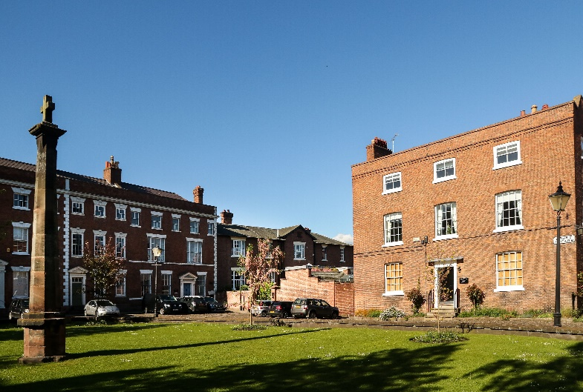
Visit the tourist information site for details of city centre car parks.

